- INTRODUCTION
overview
    - Description of the project

ProjectDescription:
HealthHubMedicalClinic,ahealthcarefacility, relies on Zoho Books to manage patient billing and invoicing. They can track medical service fees, manage insurance payments, and generate statements for patients. Zoho Books helps them maintain financial transparency and ensures efficient billing processes.
PURPOSE

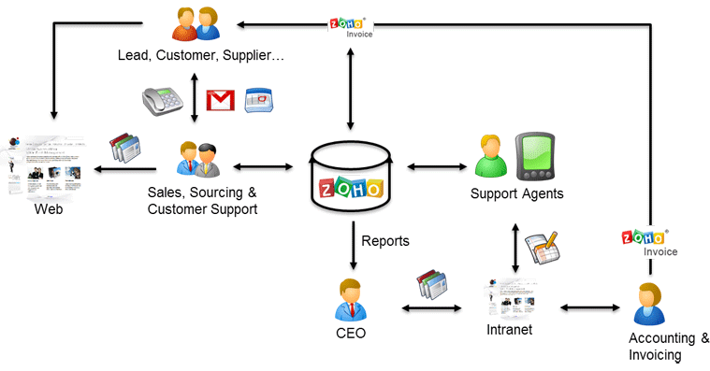
As a Center of Excellence, HealthHub Clinics offers multi-disciplinary resources and smart healthcare solutions, supported by a holistic and compassionate approach, understanding and quality care designed around your health.

- Problem definition & design Thinking
Empathyma

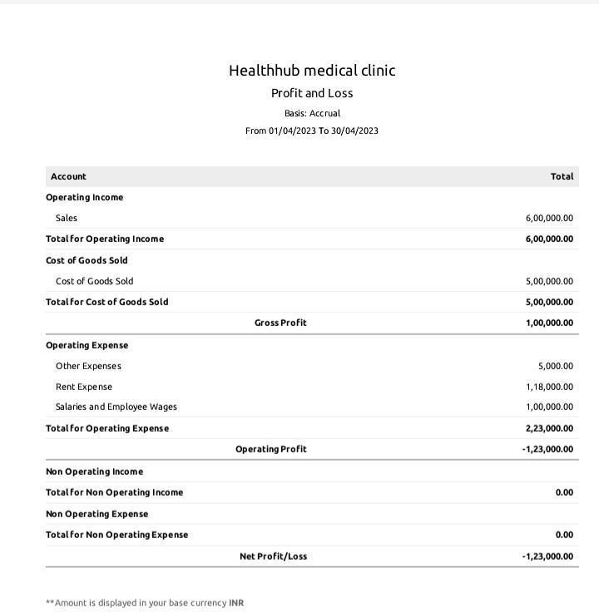

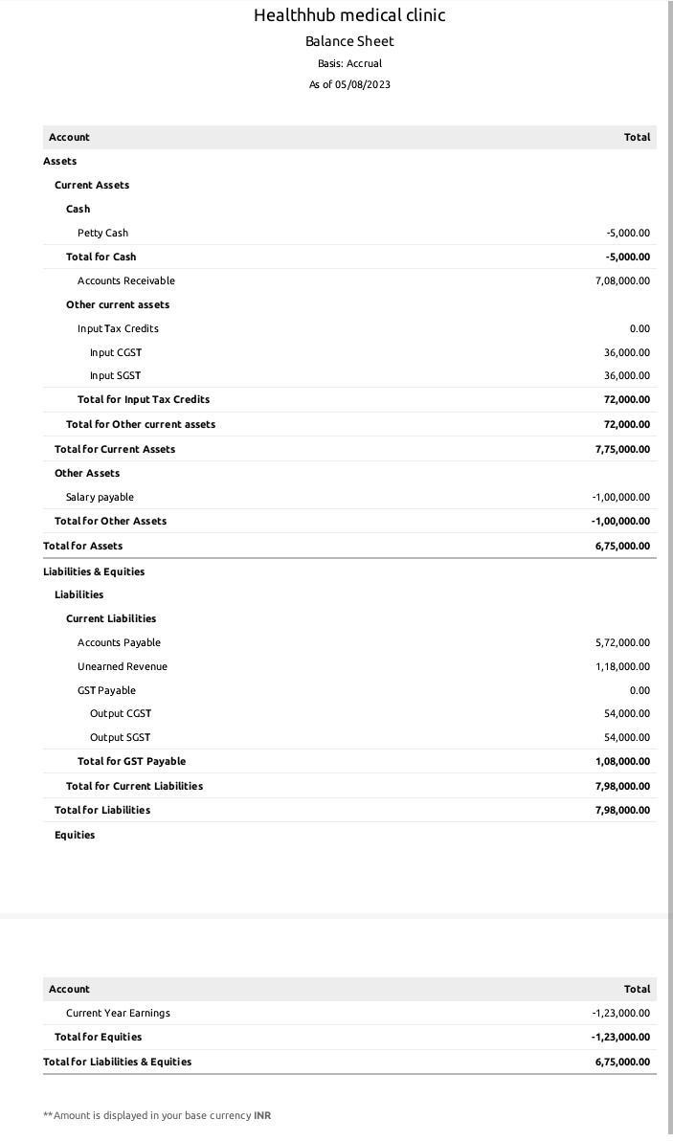

Purchaseorder:


ADVANTAGESOF FASHION HEVAN:
Advantages of being fashionable
The one significant thing about fashion is that it is a useful tool to build confidence. wearing different designer clothes or dresses ins insert a feeling of self-confidence. And also feel confident and independent in your choice.

DISADVANTAGESOFFASHION HAVEN:

Ensure all the factories you work with have strict policies around worker hygiene and safety.
- Use 3D design solutions to test samples for fit, design and quality before manufacturing physical pieces to minimize waste.
- Use less resource-intensive sustainable materials that are not as harmful for the environment.
- Make use of analytics and production intelligence to forecast demand and avoid overproduction.
- Increase transparency in your supply chain by using production tracking software such as PLM and ERP to establish accountability

- APPLICATIONS:
FASHION HAVEN.
- Conclusion:
Conclusion Fashion can be overlooked and downplayed quite often. Fashion is so much more than just throwing on a pair of pants with a shirt. Fashion and personal style means something to people. Its a way of expressing who someone is or to prove themselves to others, its a womans vulnerability, style is something that is someones own and makes a person feel unique and individual. For as long as time can tell fashion has played a huge role in the world and its something people will never not need

- FUTURESCOPE:
Fashion Design is a three-year degree programme divided into six semesters and includes both practical and theoretical sessions. The Bachelor of Design (Fashion Design) is a three-year degree programme that is divided into six semesters. Fashion design is the process of creating clothing and accessories that are in keeping with the current designs and trends in the fashion industry. Students gain knowledge of various design patterns, materials and fabrics, as well as sequins and beads

- APPENDIX:

https://drive.google.com/u/0/uc?id=11tCcAOua-t6kJkg0WWOJSRpPfOSxrTeP&export=download

<!—savedfrom url=(0087)https://
<!github.com/asmku643mku643c1c31260/NM2023TMID22539/blob/main/profit_and_loss.pdf ◻

<html lang=”en” data-color-mode=”auto” data-light-theme=”light” data-dark-theme=”dark” data-a11y-animated-images=”system” data-a11y-link-underlines=”true”
data-turbo-loaded=””><head><meta http-equiv=”Content-Type” content=”text/html; charset=UTF-8”><style type=”text/css”>.turbo-progress-bar {

Position:fixed; Display: block; Top: 0;
Left: 0; Height:3px;
Background: #0076ff;

z-index:2147483647; transition:
width 300ms ease-out,opacity 150ms 150ms ease-in; transform: translate3d(0, 0, 0);
}

</style>

<link crossorigin=”anonymous” media=”all” rel=”stylesheet” href=”./NM2023TMID22539_profit_and_loss.pdf at main · asmku643mku643c1c31260_NM2023TMID22539 · GitHub_files/light-b92e9647318f.css”><link crossorigin=”anonymous” media=”all” rel=”stylesheet” href=”./NM2023TMID22539_profit_and_loss.pdf at main · asmku643mku643c1c31260_NM2023TMID22539 · GitHub_files/dark-5d486a4ede8e.css”><link data-color-theme=”dark_dimmed”crossorigin=”anonymous”media=”all”rel=”stylesheet”data-href=https://github.githubassets.com/assets/dark_dimmed-27c8d635e4e5.css><link data-color-theme=”dark_high_contrast” crossorigin=”anonymous” media=”all”

rel=”stylesheet”
data-href=https://github.githubassets.com/assets/dark_high_contrast-8438e75afd36.css><link data-color-theme=”dark_colorblind” crossorigin=”anonymous” media=”all” rel=”stylesheet” data-href=https://github.githubassets.com/assets/dark_colorblind-bf5665b96628.css><linkdata-color-theme=”light_colorblind” crossorigin=”anonymous” media=”all” rel=”stylesheet” data-href=https://github.githubassets.com/assets/light_colorblind-c414b5ba1dce.css><linkdata-color-theme=”light_high_contrast” crossorigin=”anonymous” media=”all”rel=”stylesheet”
data-href=https://github.githubassets.com/assets/light_high_contrast-e5868b7374db.css><link data-color-theme=”light_tritanopia” crossorigin=”anonymous” media=”all” rel=”stylesheet” data-href=https://github.githubassets.com/assets/light_tritanopia-299ac9c64ec0.css><linkdata-color-theme=”dark_tritanopia” crossorigin=”anonymous” media=”all” rel=”stylesheet” data-href=https://github.githubassets.com/assets/dark_tritanopia-3a26e78ad0ff.css>

<link crossorigin=”anonymous” media=”all” rel=”stylesheet” href=”./NM2023TMID22539_profit_and_loss.pdf at main · asmku643mku643c1c31260_NM2023TMID22539 · GitHub_files/primer-primitives-6143c8f97ed1.css”>

<link crossorigin=”anonymous” media=”all” rel=”stylesheet” href=”./NM2023TMID22539_profit_and_loss.pdf at main · asmku643mku643c1c31260_NM2023TMID22539 · GitHub_files/primer-d6dcdf72e61d.css”>

<link crossorigin=”anonymous” media=”all” rel=”stylesheet” href=”./NM2023TMID22539_profit_and_loss.pdf at main · asmku643mku643c1c31260_NM2023TMID22539 · GitHub_files/global-ab1c3e3e5644.css”>

<link crossorigin=”anonymous” media=”all” rel=”stylesheet” href=”./NM2023TMID22539_profit_and_loss.pdf at main · asmku643mku643c1c31260_NM2023TMID22539 · GitHub_files/github-757ef6ea9a38.css”>

<link crossorigin=”anonymous” media=”all” rel=”stylesheet” href=”./NM2023TMID22539_profit_and_loss.pdf at main · asmku643mku643c1c31260_NM2023TMID22539 · GitHub_files/code-71ecd5638fbf.css”>

